Cardinal Numbers (Numerical Quantifiers)

🔢 What Are Cardinal Numbers (Numerical Quantifiers)?
# Source: AI Source: Provided by: [Data Path: Persons Table -> ID Column: 1, Name_En Column: Motasem Essam] -> From: [ChatGPT] on [7/28/2025]
Cardinal numbers are numerical quantifiers that tell “how many” of something there are.
They express quantity — exact counts — and answer the question: “How many?”

✅ Examples of Cardinal Numbers:
# Source: AI Source: Provided by: [Data Path: Persons Table -> ID Column: 1, Name_En Column: Motasem Essam] -> From: [ChatGPT] on [7/28/2025]
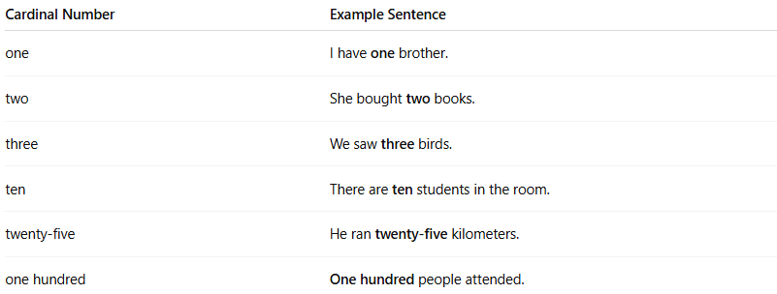
Cardinal Number | Example Sentence
one | I have one brother.
two | She bought two books.
three | We saw three birds.
ten | There are ten students in the room.
twenty-five | He ran twenty-five kilometers.
one hundred | One hundred people attended.

💡 Cardinal Numbers vs Ordinal Numbers:
# Source: AI Source: Provided by: [Data Path: Persons Table -> ID Column: 1, Name_En Column: Motasem Essam] -> From: [ChatGPT] on [7/28/2025]

Cardinal (Quantity) | Ordinal (Order/Position)
one, two, three | first, second, third
ten, eleven, twelve | tenth, eleventh, twelfth

